Chapter 10
Bond Prices and Yields

  - Catastrophe bond. Typically issued by an insurance company. They are similar to an insurance policy in that the investor receives coupons and par value, but takes a loss in part or all of the principal if a major insurance claims is filed against the issuer. This is provided in exchange for higher than normal coupons.
  - Eurobonds are bonds issued in the currency of one country but sold in other national markets.
  - Zero-coupon bonds are bonds that pay no coupons, but do pay a par value at maturity.
  - Samurai bond. Yen-denominated bonds sold in Japan by non-Japanese issuers are called Samurai bonds.
  - Junk bond. Those rated BBB or above (S&P, Fitch) or Baa and above (Moody’s) are considered investment grade bonds, while lower-rated bonds are classified as speculative grade or junk bonds.
  - Convertible bond. Convertible bonds may be exchanged, at the bondholder’s discretion, for a specified number of shares of stock. Convertible bondholders “pay” for this option by accepting a lower coupon rate on the security.
  - Serial bond. A serial bond is an issue in which the firm sells bonds with staggered maturity dates. As bonds mature sequentially, the principal repayment burden for the firm is spread over time just as it is with a sinking fund. Serial bonds do not include call provisions.
  - Equipment obligation bond. A bond that is issued with specific equipment pledged as collateral against the bond.
  - Original issue discount bonds are less common than coupon bonds issued at par. These are bonds that are issued intentionally with low coupon rates that cause the bond to sell at a discount from par value.
  - Indexed bond. Indexed bonds make payments that are tied to a general price index or the price of a particular commodity.

- Callable bonds give the issuer the option to extend or retire the bond at the call date, while the extendable or puttable bond gives this option to the bondholder.

  - YTM will drop since the company has more money to pay the interest on its bonds.
  - YTM will increases since the company has more debt and the risk to the existing bond holders is now increased.
  - YTM will decrease. Since the firm has either fewer current liabilities or an increase in various current assets.

- Semi-annual coupon = 1,000 x .06 x .5 = $30. One month of accrued interest is 30 x (30/182) 4.945. at a price of 117 the invoice price is 1,170 + 4.945 = $1,174.95

- Using a financial calculator, PV = -746.22, FV = 1,000, t=5, pmt = 0. The YTM is 6.0295%.
Using a financial calculator, PV = -730.00, FV = 1,000, t=5, pmt = 0. The YTM is 6.4965%.

- A bond’s coupon interest payments and principal repayment are not affected by changes in market rates. Consequently, if market rates increase, bond investors in the secondary markets are not willing to pay as much for a claim on a given bond’s fixed interest and principal payments as they would if market rates were lower. This relationship is apparent from the inverse relationship between interest rates and present value. An increase in the discount rate (i.e., the market rate) decreases the present value of the future cash flows.

- The bond callable at 105 should sell at a lower price because the call provision is more valuable to the firm. Therefore, its yield to maturity should be higher.

- The bond price will be lower. As time passes, the bond price, which is now above par value, will approach par.

- Current yield = 48 / 970 = 4.95%

- Using a financial calculator, FV = 1,000, t=7, pmt = 60, r=7. Price = 946.11
The HPR = (946.11 – 1000 + 60) / 1000 = .0061 or 0.61% gain.

- Zero coupon bonds provide no coupons to be reinvested. Therefore, the final value of the investor's proceeds from the bond is independent of the rate at which coupons could be reinvested (if they were paid). There is no reinvestment rate uncertainty with zeros.

  - Effective annual rate on three-month T-bill:
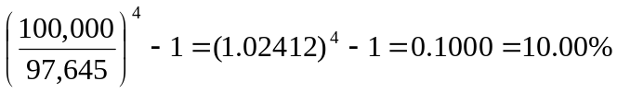
  - Effective annual interest rate on coupon bond paying 5% semiannually:
(1.05)2 – 1 = 0.1025 = 10.25%
Therefore, the coupon bond has the higher effective annual interest rate.

- The effective annual yield on the semiannual coupon bonds is 8.16%. If the annual coupon bonds are to sell at par they must offer the same yield, which requires an annual coupon of 8.16%.

  - The bond pays $50 every six months.
Current price:
[$50 × Annuity factor(4%, 6)] + [$1000 × PV factor(4%, 6)] = $1,052.42
Assuming the market interest rate remains 4% per half year, price six months from now:
[$50 × Annuity factor(4%, 5)] + [$1000 × PV factor(4%, 5)] = $1,044.52
  - Rate of return =

  - Use the following inputs: n = 40, FV = 1000, PV = –950, PMT = 40. You will find that the yield to maturity on a semi-annual basis is 4.26%. This implies a bond equivalent yield to maturity of: 4.26% × 2 = 8.52%
Effective annual yield to maturity = (1.0426)2 – 1 = 0.0870 = 8.70%
  - Since the bond is selling at par, the yield to maturity on a semi-annual basis is the same as the semi-annual coupon, 4%. The bond equivalent yield to maturity is 8%.
Effective annual yield to maturity = (1.04)2 – 1 = 0.0816 = 8.16%
  - Keeping other inputs unchanged but setting PV = –1050, we find a bond equivalent yield to maturity of 7.52%, or 3.76% on a semi-annual basis.
Effective annual yield to maturity = (1.0376)2 – 1 = 0.0766 = 7.66%

- Since the bond payments are now made annually instead of semi-annually, the bond equivalent yield to maturity is the same as the effective annual yield to maturity. The inputs are: n = 20, FV = 1000, PV = –price, PMT = 80. The resulting yields for the three bonds are:
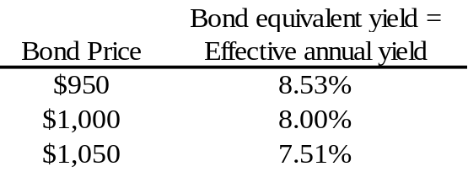

The yields computed in this case are lower than the yields calculated with semi-annual coupon payments. All else equal, bonds with annual payments are less attractive to investors because more time elapses before payments are received. If the bond price is the same with annual payments, then the bond's yield to maturity is lower.

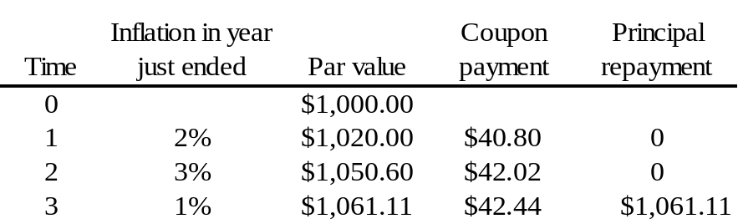
Nominal return = 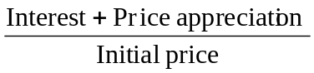
Real return = 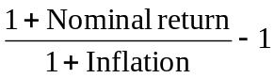

 | Second year | Third year
Nominal return: | 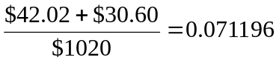 | 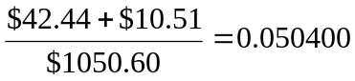
Real return: | 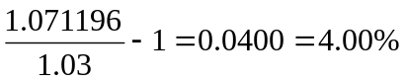 | 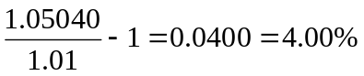
The real rate of return in each year is precisely the 4% real yield on the bond.

- Remember that the convention is to use semi-annual periods:
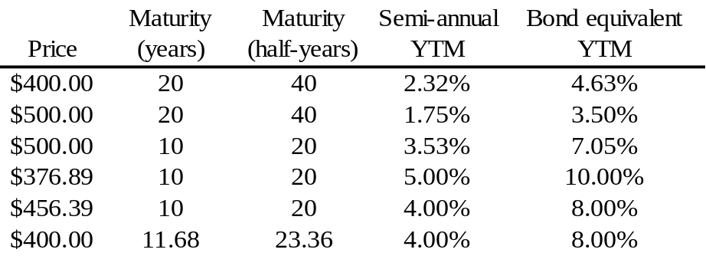

- Using a financial calculator, PV = -800, FV = 1,000, t=10, pmt =80. The YTM is 11.46%.
Using a financial calculator, FV = 1,000, t=9, pmt =80, r=11.46%. The new price will be 811.70. Thus, the capital gain is $11.70.

- The reported bond price is: 100 2/32 percent of par = $1,000.625
However, 15 days have passed since the last semiannual coupon was paid, so accrued interest equals: $35 x (15/182) = $2.885
The invoice price is the reported price plus accrued interest: $1003.51

- If the yield to maturity is greater than current yield, then the bond offers the prospect of price appreciation as it approaches its maturity date. Therefore, the bond is selling below par value.

- The coupon rate is below 9%. If coupon divided by price equals 9%, and price is less than par, then coupon divided by par is less than 9%.

- The solution is obtained using Excel:

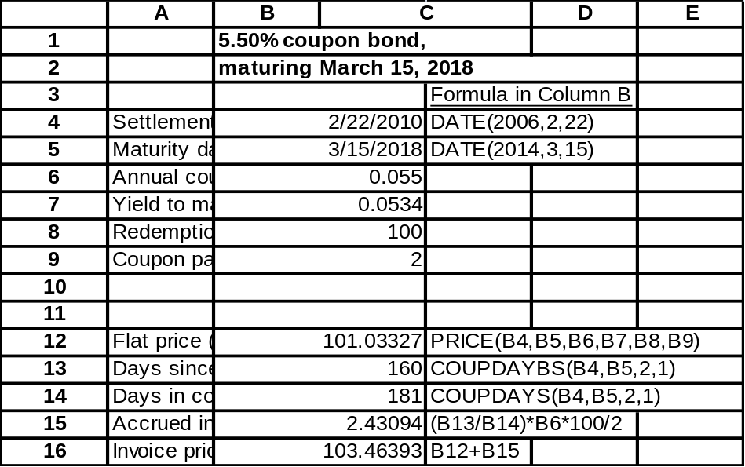

- The solution is obtained using Excel:

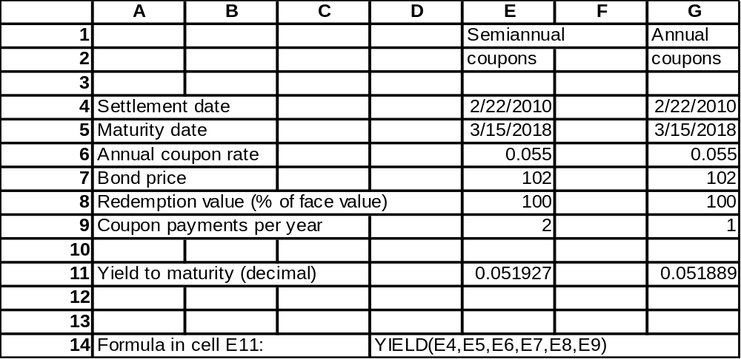
- The stated yield to maturity equals 16.075%:
[n = 10; PV = 900; FV = 1000; PMT = 140]
Based on expected coupon payments of $70 annually,
the expected yield to maturity is: 8.526%

- The bond is selling at par value. Its yield to maturity equals the coupon rate, 10%. If the first-year coupon is reinvested at an interest rate of r percent, then total proceeds at the end of the second year will be: [100 × (1 + r) + 1100]. Therefore, realized compound yield to maturity will be a function of r as given in the following table:

r | Total proceeds | Realized YTM = 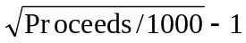
8% | $1208 | 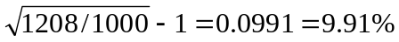
10% | $1210 | 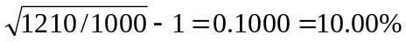
12% | $1212 | 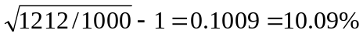

- April 15 is midway through the semi-annual coupon period. Therefore, the invoice price will be higher than the stated ask price by an amount equal to one-half of the semiannual coupon. The ask price is 101.125 percent of par, so the invoice price is:
$1,011.25 + (1/2 × $50) = $1,036.25

- Factors that might make the ABC debt more attractive to investors, therefore justifying a lower coupon rate and yield to maturity, are:
- The ABC debt is a larger issue and therefore may sell with greater liquidity.
  - An option to extend the term from 10 years to 20 years is favorable if interest rates ten years from now are lower than today’s interest rates. In contrast, if interest rates are rising, the investor can present the bond for payment and reinvest the money for better returns.
  - In the event of trouble, the ABC debt is a more senior claim. It has more underlying security in the form of a first claim against real property.
  - The call feature on the XYZ bonds makes the ABC bonds relatively more attractive since ABC bonds cannot be called from the investor.
  - The XYZ bond has a sinking fund requiring XYZ to retire part of the issue each year. Since most sinking funds give the firm the option to retire this amount at the lower of par or market value, the sinking fund can work to the detriment of bondholders.

  - The floating-rate note pays a coupon that adjusts to market levels. Therefore, it will not experience dramatic price changes as market yields fluctuate. The fixed rate note therefore will have a greater price range.

  - Floating rate notes may not sell at par for any of the several reasons: The yield spread between one-year Treasury bills and other money market instruments of comparable maturity could be wider than it was when the bond was issued.

The credit standing of the firm may have eroded relative to Treasury securities that have no credit risk. Therefore, the 2% premium would become insufficient to sustain the issue at par.

The coupon increases are implemented with a lag, i.e., once every year. During a period of rising interest rates, even this brief lag will be reflected in the price of the security.

  - The risk of call is low. Because the bond will almost surely not sell for much above par value (given its adjustable coupon rate), it is unlikely that the bond will ever be called.

  - The fixed-rate note currently sells at only 93% of the call price, so that yield to maturity is above the coupon rate. Call risk is currently low, since yields would have to fall substantially for the firm to use its option to call the bond.

  - The 9% coupon notes currently have a remaining maturity of fifteen years and sell at a yield to maturity of 9.9%. This is the coupon rate that would be needed for a newly issued fifteen-year maturity bond to sell at par.

  - Because the floating rate note pays a variable stream of interest payments to maturity, its yield-to-maturity is not a well-defined concept. The cash flows one might want to use to calculate yield to maturity are not yet known. The effective maturity for comparing interest rate risk of floating rate debt securities with other debt securities is better thought of as the next coupon reset date rather than the final maturity date. Therefore, “yield-to-recoupon date” is a more meaningful measure of return.

  - The bond sells for $1,124.72 based on the 3.5% yield to maturity:
[n = 60; i = 3.5; FV = 1000; PMT = 40]
Therefore, yield to call is 3.368% semiannually, 6.736% annually:
[n = 10; PV = 1124.72; FV = 1100; PMT = 40]
  - If the call price were $1050, we would set FV = 1050 and redo part (a) to find that yield to call is 2.976% semi-annually, 5.952% annually. With a lower call price, the yield to call is lower.

  - Yield to call is 3.031% semiannually, 6.062% annually:
[n = 4; PV = 1124.72 ; FV = 1100; PMT = 40]

- The price schedule is as follows:
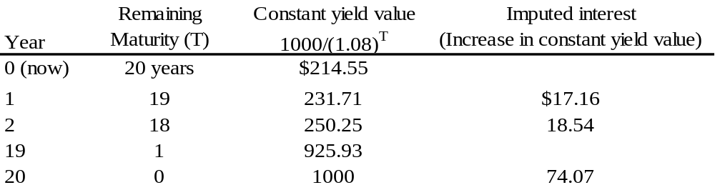

- The bond is issued at a price of $800. Therefore, its yield to maturity is 6.8245%. Using the constant yield method, we can compute that its price in one year (when maturity falls to 9 years) will be (at an unchanged yield) $814.60, representing an increase of $14.60. Total taxable income is: $40 + $14.60 = $54.60

  - The yield to maturity of the par bond equals its coupon rate, 8.75%. All else equal, the 4% coupon bond would be more attractive because its coupon rate is far below current market yields, and its price is far below the call price. Therefore, if yields fall, capital gains on the bond will not be limited by the call price. In contrast, the 8.75% coupon bond can increase in value to at most $1050, offering a maximum possible gain of only 5%. The disadvantage of the 8.75% coupon bond in terms of vulnerability to a call shows up in its higher promised yield to maturity.

  - If an investor expects rates to fall substantially, the 4% bond offers a greater expected return.

  - Implicit call protection is offered in the sense that any likely fall in yields would not be nearly enough to make the firm consider calling the bond. In this sense, the call feature is almost irrelevant.

- True. Under the expectations hypothesis, there are no risk premia built into bond prices. The only reason for long-term yields to exceed short-term yields is an expectation of higher short-term rates in the future.

- If the yield curve is upward sloping, you cannot conclude that investors expect short-term interest rates to rise because the rising slope could be due to either expectations of future increases in rates or the demand of investors for a risk premium on long-term bonds. In fact the yield curve can be upward sloping even in the absence of expectations of future increases in rates.

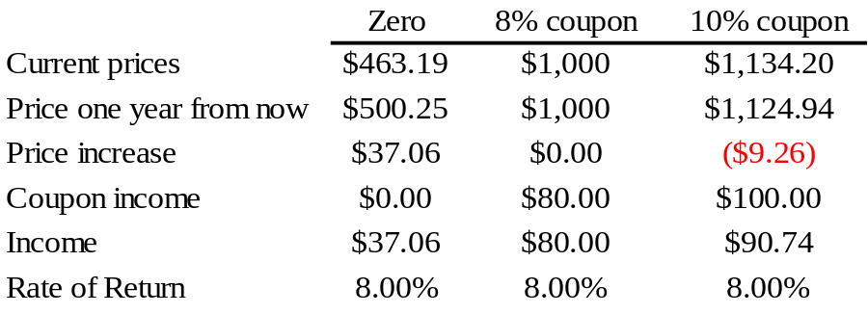

- Uncertain. Lower inflation usually leads to lower nominal interest rates. Nevertheless, if the liquidity premium is sufficiently great, long-term yields can exceed short-term yields despite expectations of falling short rates.

  - We obtain forward rates from the following table:
Maturity  (years) | YTM | Forward rate | Price (for part c)
1 | 10.0% |  | $909.09 ($1000/1.10)
2 | 11.0% | 12.01% [(1.11²/1.10) – 1] | $811.62 ($1000/1.11²)
3 | 12.0% | 14.03% [(1.12³/1.11²) – 1] | $711.78 ($1000/1.12³)

  - We obtain next year’s prices and yields by discounting each zero’s face value at the forward rates derived in part (a):
Maturity  (years) | Price |  | YTM
1 | $892.78 | [ = 1000/1.1201] | 12.01%
2 | $782.93 | [ = 1000/(1.1201 x 1.1403)] | 13.02%
Note that this year’s upward sloping yield curve implies, according to the expectations hypothesis, a shift upward in next year’s curve.

  - Next year, the two-year zero will be a one-year zero, and it will therefore sell at: $1000/1.1201 = $892.78
Similarly, the current three-year zero will be a two-year zero, and it will sell for: $782.93
Expected total rate of return:
two-year bond: 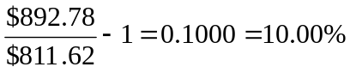
three-year bond: 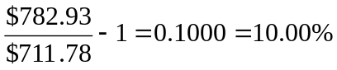

  - The forward rate (f₂) is the rate that makes the return from rolling over one-year bonds the same as the return from investing in the two-year maturity bond and holding to maturity:
1.08 × (1 + f₂) = (1.09)2 ⇒ f₂ = 0.1001 = 10.01%
  - According to the expectations hypothesis, the forward rate equals the expected value of the short-term interest rate next year, so the best guess would be 10.01%.

  - According to the liquidity preference hypothesis, the forward rate exceeds the expected short-term interest rate next year, so the best guess would be less than 10.01%.

- The top row must be the spot rates. The spot rates are (geometric) averages of the forward rates, and the top row is the average of the bottom row. For example, the spot rate on a two-year investment (12%) is the average of the two forward rates 10% and 14.0364%:
(1.12)² = 1.10 × 1.140364 = 1.2544

- Using a financial calculator, PV = 100, t=3, pmt=0, r=6.5. Price or FV = 120.795. Using a financial calculator, PV = 100, t=4, pmt=0, r=7.0. Price or FV = 131.080.
Setting PV = -120.795, FV = 131.080, t=1, pmt=0, solving for r produces the answer of 8.51%.

  - Initial price, P0 = 705.46 [n = 20; PMT = 50; FV = 1000; i = 8]
Next year's price, P1 = 793.29 [n = 19; PMT = 50; FV = 1000; i = 7]
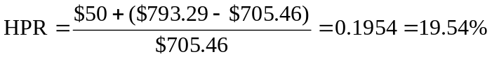
  - Using OID tax rules, the cost basis and imputed interest under the constant yield method are obtained by discounting bond payments at the original 8% yield to maturity, and simply reducing maturity by one year at a time:

Constant yield prices: compare these to actual prices to compute capital gains
P0 = $705.46
P1 = $711.89 so implicit interest over first year = $6.43
P2 = $718.84 so implicit interest over second year = $6.95
Tax on explicit plus implicit interest in first year
= 0.40 × ($50 + $6.43) = $22.57
Capital gain in first year = Actual price at 7% YTM – constant yield price
= $793.29 – $711.89 = $81.40
Tax on capital gain = 0.30 × $81.40 = $24.42
Total taxes = $22.57 + $24.42 = $46.99
  - After tax HPR 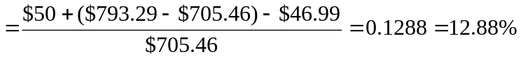
  - Value of bond after two years equals $798.82 [using n = 18; i = 7]
Total income from the two coupons, including reinvestment income:
($50 × 1.03) + $50 = $101.50
Total funds after two years: $798.82 + $101.50 = $900.32
Therefore, the $705.46 investment grows to $900.32 after two years.
  - (1 + r)2 = 900.32 ⇒ r = 0.1297 = 12.97%

Coupon received in first year: $50.00
Tax on coupon @ 40% – 20.00
Tax on imputed interest (0.40 × $6.43) – 2.57
Net cash flow in first year $27.43

If you invest the year-1 cash flow at an after-tax rate of:
3% × (1 – 0.40) = 1.8%
then, by year 2, it will grow to:
$27.43 × 1.018 = $27.92

You sell the bond in the second year for: $798.82
Tax on imputed interest in second year: – 2.78 [0.40 × $6.95]
Coupon received in second year, net of tax: + 30.00 [$50 × (1 – 0.40)]
Capital gains tax on sales price: – 23.99 [0.30 × ($798.82 – $718.84)]
using constant yield value
CF from first year's coupon (reinvested): + 27.92 [from above]
TOTAL $829.97
Thus, after two years, the initial investment of $705.46 grows to $829.97:
705.46 × (1 + r)2 = 829.97 ⇒ r = 0.0847 = 8.47%

CFA 1
- (3) The yield on the callable bond must compensate the investor for the risk of call.
Choice (1) is wrong because, although the owner of a callable bond receives principal plus a premium in the event of a call, the interest rate at which he can subsequently reinvest will be low. The low interest rate that makes it profitable for the issuer to call the bond makes it a bad deal for the bond’s holder.
Choice (2) is wrong because a bond is more apt to be called when interest rates are low. There will be an interest saving for the issuer only if rates are low.

- (3)
- (2)
- (4)

CFA 2
  - The maturity of each bond is 10 years, and we assume that coupons are paid semiannually. Since both bonds are selling at par value, the current yield to maturity for each bond is equal to its coupon rate.

If the yield declines by 1%, to 5% (2.5% semiannual yield), the Sentinal bond will increase in value to 107.79 [n=20; i = 2.5%; FV = 100; PMT = 3]
The price of the Colina bond will increase, but only to the call price of 102. The present value of scheduled payments is greater than 102, but the call price puts a ceiling on the actual bond price.

  - If rates are expected to fall, the Sentinal bond is more attractive: since it is not subject to being called, its potential capital gains are higher.

If rates are expected to rise, Colina is a better investment. Its higher coupon (which presumably is compensation to investors for the call feature of the bond) will provide a higher rate of return than the Sentinal bond.

  - An increase in the volatility of rates increases the value of the firm’s option to call back the Colina bond. [If rates go down, the firm can call the bond, which puts a cap on possible capital gains. So, higher volatility makes the option to call back the bond more valuable to the issuer.] This makes the Colina bond less attractive to the investor.

CFA 3
Market conversion value = value if converted into stock = 20.83 × $28 = $583.24
Conversion premium = Bond value – market conversion value
= $775 – $583.24 = $191.76

CFA 4
  - The call provision requires the firm to offer a higher coupon (or higher promised yield to maturity) on the bond in order to compensate the investor for the firm's option to call back the bond at a specified call price if interest rates fall sufficiently. Investors are willing to grant this valuable option to the issuer, but only for a price that reflects the possibility that the bond will be called. That price is the higher promised yield at which they are willing to buy the bond.

  - The call option reduces the expected life of the bond. If interest rates fall substantially so that the likelihood of call increases, investors will treat the bond as if it will "mature" and be paid off at the call date, not at the stated maturity date. On the other hand if rates rise, the bond must be paid off at the maturity date, not later. This asymmetry means that the expected life of the bond will be less than the stated maturity.

  - The advantage of a callable bond is the higher coupon (and higher promised yield to maturity) when the bond is issued. If the bond is never called, then an investor will earn a higher realized compound yield on a callable bond issued at par than on a non-callable bond issued at par on the same date. The disadvantage of the callable bond is the risk of call. If rates fall and the bond is called, then the investor receives the call price and will have to reinvest the proceeds at interest rates that are lower than the yield to maturity at which the bond was originally issued. In this event, the firm's savings in interest payments is the investor's loss.

CFA 5

(1) Current yield = Coupon/Price = 70/960 = 0.0729 = 7.29%
(2) YTM = 3.993% semiannually or 7.986% annual bond equivalent yield
[n = 10; PV = (-)960; FV = 1000; PMT = 35]
Then compute the interest rate.
- Realized compound yield is 4.166% (semiannually), or 8.332% annual bond equivalent yield. To obtain this value, first calculate the future value of reinvested coupons. There will be six payments of $35 each, reinvested semiannually at a per period rate of 3%:
[PV = 0; PMT = $35; n = 6; i = 3%] Compute FV = $226.39
The bond will be selling at par value of $1,000 in three years, since coupon is forecast to equal yield to maturity. Therefore, total proceeds in three years will be $1,226.39. To find realized compound yield on a semiannual basis (i.e., for six half-year periods), we solve:
$960 × (1 + y_{realized})6 = $1,226.39 ⇒ y_{realized} = 4.166% (semiannual)
- Shortcomings of each measure:
(1) Current yield does not account for capital gains or losses on bonds bought at prices other than par value. It also does not account for reinvestment income on coupon payments.
(2) Yield to maturity assumes that the bond is held to maturity and that all coupon income can be reinvested at a rate equal to the yield to maturity.
(3) Realized compound yield (horizon yield) is affected by the forecast of reinvestment rates, holding period, and yield of the bond at the end of the investor's holding period.

